1. For angular to work we need one additional tool ie. Node.js. so we need to Install node.js in our system

* Node.js is a javascript runtime built on chrome’s V8 javascript engine. Node.js uses an event-driven, non-blocking I/O model that makes it lightweight and efficient.
* Node.js package ecosystem, npm is the largest ecosystem of open sources libraries in the world
* Nodejs is used behind the scenes by the CLi to bundle and optimize our project
* NPM - Node package manager is used to manage different dependancies in angular project
* Can be downloaded from here: <https://nodejs.org/en/download/>
* Once installed we will be able to use npm CLI in our system

1. Install angular using below command:

*C:\Users\Maheswaran****>npm install -g @angular/cli@latest***

*npm WARN deprecated @npmcli/move-file@2.0.1: This functionality has been moved to @npmcli/fs*

*added 224 packages, and audited 225 packages in 39s*

*26 packages are looking for funding*

*run `npm fund` for details*

*found 0 vulnerabilities*

*npm notice*

*npm notice New major version of npm available! 8.19.3 -> 9.3.1*

*npm notice Changelog: https://github.com/npm/cli/releases/tag/v9.3.1*

*npm notice Run npm install -g npm@9.3.1 to update!*

*npm notice*

* -g in CLI means installing globally in our machine

1. To get angular version: ng version

*######################*

*C:\Users\Maheswaran>ng version*

*_ _ ____ _ ___*

*/ \ _ __ __ _ _ _| | __ _ _ __ / ___| | |_ _|*

*/ △ \ | '_ \ / _` | | | | |/ _` | '__| | | | | | |*

*/ ___ \| | | | (_| | |_| | | (_| | | | |___| |___ | |*

*/_/ \_\_| |_|\__, |\__,_|_|\__,_|_| \____|_____|___|*

*|___/*

*Angular CLI: 15.1.2*

*Node: 18.13.0*

*Package Manager: npm 9.3.1*

*OS: win32 x64*

*Angular:*

*...*

*Package Version*

*------------------------------------------------------*

*@angular-devkit/architect 0.1501.2 (cli-only)*

*@angular-devkit/core 15.1.2 (cli-only)*

*@angular-devkit/schematics 15.1.2 (cli-only)*

*@schematics/angular 15.1.2 (cli-only)*

*##################*

1. To create a new angular project:ng new my-first-appmahe --no-strict

-> new folder will be created in the name given

-> Strict mode is a special mode in which we can create our projects

-> routing is needed or not needs to be specified

-> also we need to specify stylesheet format

###########################

*E:\Expeditors_sample_projects\Angular_Projects>ng new my-first-appmahe --no-strict*

*? Would you like to add Angular routing? No*

*? Which stylesheet format would you like to use? CSS*

*CREATE my-first-appmahe/angular.json (2749 bytes)*

*CREATE my-first-appmahe/package.json (1047 bytes)*

*CREATE my-first-appmahe/README.md (1068 bytes)*

*CREATE my-first-appmahe/tsconfig.json (576 bytes)*

*CREATE my-first-appmahe/.editorconfig (274 bytes)*

*CREATE my-first-appmahe/.gitignore (548 bytes)*

*CREATE my-first-appmahe/tsconfig.app.json (263 bytes)*

*CREATE my-first-appmahe/tsconfig.spec.json (273 bytes)*

*CREATE my-first-appmahe/.vscode/extensions.json (130 bytes)*

*CREATE my-first-appmahe/.vscode/launch.json (474 bytes)*

*CREATE my-first-appmahe/.vscode/tasks.json (938 bytes)*

*CREATE my-first-appmahe/src/favicon.ico (948 bytes)*

*CREATE my-first-appmahe/src/index.html (300 bytes)*

*CREATE my-first-appmahe/src/main.ts (214 bytes)*

*CREATE my-first-appmahe/src/styles.css (80 bytes)*

*CREATE my-first-appmahe/src/assets/.gitkeep (0 bytes)*

*CREATE my-first-appmahe/src/app/app.module.ts (314 bytes)*

*CREATE my-first-appmahe/src/app/app.component.html (23083 bytes)*

*CREATE my-first-appmahe/src/app/app.component.spec.ts (986 bytes)*

*CREATE my-first-appmahe/src/app/app.component.ts (220 bytes)*

*CREATE my-first-appmahe/src/app/app.component.css (0 bytes)*

*√ Packages installed successfully.*

*warning: in the working copy of '.editorconfig', LF will be replaced by CRLF the next time Git touches it*

*warning: in the working copy of '.gitignore', LF will be replaced by CRLF the next time Git touches it*

*warning: in the working copy of '.vscode/extensions.json', LF will be replaced by CRLF the next time Git touches it*

*warning: in the working copy of '.vscode/launch.json', LF will be replaced by CRLF the next time Git touches it*

*warning: in the working copy of '.vscode/tasks.json', LF will be replaced by CRLF the next time Git touches it*

*warning: in the working copy of 'README.md', LF will be replaced by CRLF the next time Git touches it*

*warning: in the working copy of 'angular.json', LF will be replaced by CRLF the next time Git touches it*

*warning: in the working copy of 'package-lock.json', LF will be replaced by CRLF the next time Git touches it*

*warning: in the working copy of 'package.json', LF will be replaced by CRLF the next time Git touches it*

*warning: in the working copy of 'src/app/app.component.html', LF will be replaced by CRLF the next time Git touches it*

*warning: in the working copy of 'src/app/app.component.spec.ts', LF will be replaced by CRLF the next time Git touches it*

*warning: in the working copy of 'src/app/app.component.ts', LF will be replaced by CRLF the next time Git touches it*

*warning: in the working copy of 'src/app/app.module.ts', LF will be replaced by CRLF the next time Git touches it*

*warning: in the working copy of 'src/index.html', LF will be replaced by CRLF the next time Git touches it*

*warning: in the working copy of 'src/main.ts', LF will be replaced by CRLF the next time Git touches it*

*warning: in the working copy of 'src/styles.css', LF will be replaced by CRLF the next time Git touches it*

*warning: in the working copy of 'tsconfig.app.json', LF will be replaced by CRLF the next time Git touches it*

*warning: in the working copy of 'tsconfig.json', LF will be replaced by CRLF the next time Git touches it*

*warning: in the working copy of 'tsconfig.spec.json', LF will be replaced by CRLF the next time Git touches it*

*Successfully initialized git.*

*E:\Expeditors_sample_projects\Angular_Projects>*

####################################

1. Once project created successfully, we can navigate to that folder and see the contents

#######################################

*E:\Expeditors_sample_projects\Angular_Projects>cd my-first-appmahe*

*E:\Expeditors_sample_projects\Angular_Projects\my-first-appmahe>dir*

*Volume in drive E is New Volume*

*Volume Serial Number is 3268-C7F8*

*Directory of E:\Expeditors_sample_projects\Angular_Projects\my-first-appmahe*

*21-01-2023 06:22 <DIR> .*

*21-01-2023 06:20 <DIR> ..*

*21-01-2023 06:20 274 .editorconfig*

*21-01-2023 06:20 548 .gitignore*

*21-01-2023 06:20 <DIR> .vscode*

*21-01-2023 06:20 2,749 angular.json*

*21-01-2023 06:21 <DIR> node_modules*

*21-01-2023 06:22 413,477 package-lock.json*

*21-01-2023 06:20 1,047 package.json*

*21-01-2023 06:20 1,068 README.md*

*21-01-2023 06:20 <DIR> src*

*21-01-2023 06:20 263 tsconfig.app.json*

*21-01-2023 06:20 576 tsconfig.json*

*21-01-2023 06:20 273 tsconfig.spec.json*

*9 File(s) 420,275 bytes*

*5 Dir(s) 525,672,030,208 bytes free*

#########################################

1. Bringing up development server: ng serve

-> we will do this to bring up our development server, which will run our build and have development optimized app, so that we can see the same in the browser

-> The server runs on localhost:4200 by default

#########################################

*E:\Expeditors_sample_projects\Angular_Projects\my-first-appmahe>ng serve*

*? Would you like to share pseudonymous usage data about this project with the Angular Team*

*at Google under Google's Privacy Policy at https://policies.google.com/privacy. For more*

*details and how to change this setting, see https://angular.io/analytics. Yes*

*Thank you for sharing pseudonymous usage data. Should you change your mind, the following*

*command will disable this feature entirely:*

*ng analytics disable*

*Global setting: enabled*

*Local setting: enabled*

*Effective status: enabled*

*√ Browser application bundle generation complete.*

*Initial Chunk Files | Names | Raw Size*

*vendor.js | vendor | 1.71 MB |*

*polyfills.js | polyfills | 314.29 kB |*

*styles.css, styles.js | styles | 209.41 kB |*

*main.js | main | 46.01 kB |*

*runtime.js | runtime | 6.53 kB |*

*| Initial Total | 2.27 MB*

*Build at: 2023-01-21T01:02:18.716Z - Hash: 55ec95172a51766e - Time: 11152ms*

*\*\* Angular Live Development Server is listening on localhost:4200, open your browser on http://localhost:4200/ \*\**

*√ Compiled successfully.*

#########################################

1. We can verify the same using localhost:4200

<http://localhost:4200/>

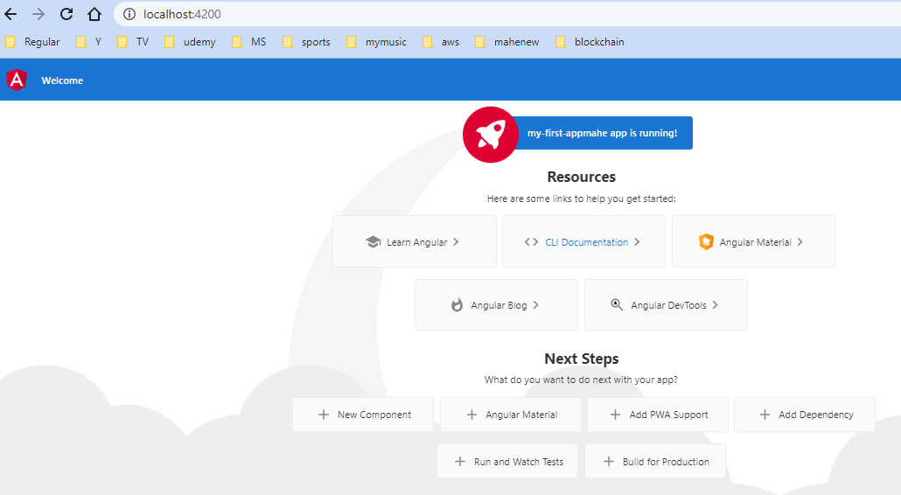

1. We can import the project which is present in folder into our IDE: Visual Studio code

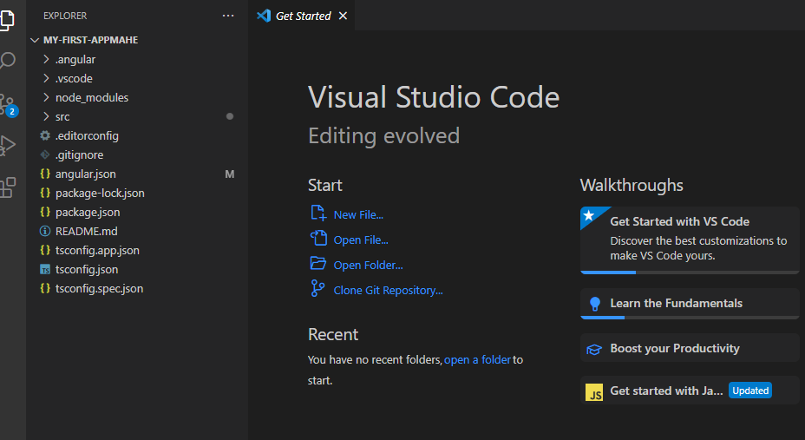

1. In package.json file – we can see the name of the application, application dependencies and dev dependencies

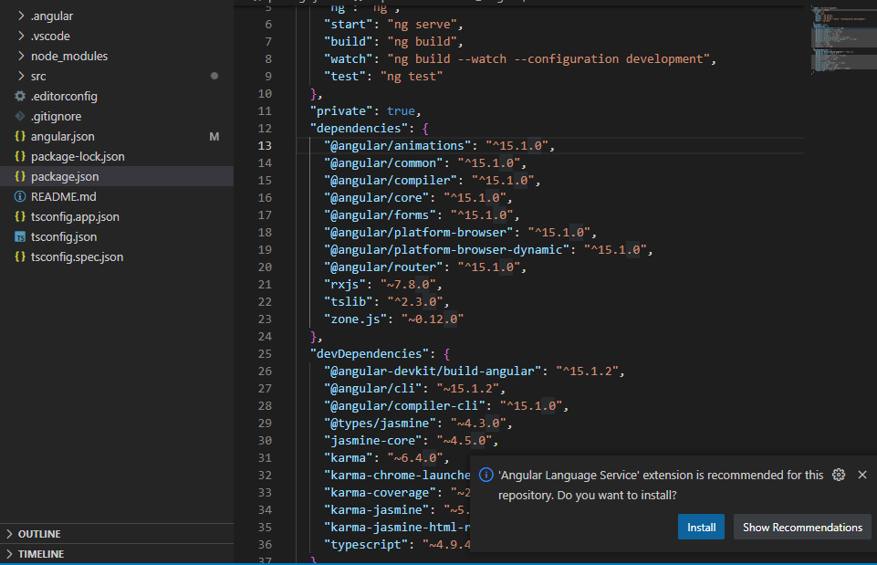

1. Walkthrough on folders

* E2e for end to end testing
* Node_modules – where all dependencies mentioned in package.json file are installed

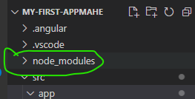

* To understand the capabilities of the Angular framework, you need to learn about the following:
  + - Components
    - Templates
    - Directives
    - Dependency injection

**Components:**

Components are the main building block for Angular applications. Each component(eg:app) consists of:

1. An HTML template that declares what renders on the page(app.component.html)
2. A TypeScript class that defines behaviour(app.component.ts). Typescript file contains the definition of component
3. A CSS selector that defines how the component is used in a template(app.component.css)

Optionally, CSS styles applied to the template

* app.component.html ->

*E:\Expeditors_sample_projects\Angular_Projects\my-first-appmahe\src\app\app.component.html*

* For the below line in app.component.html. title is the dynamic part.

*Welcome to Mahesh's {{ title }}!*

* This is fetched from definition file: app.component.ts

*export class AppComponent {*

*title = 'my-first-appmahe';*

*}*

* If we see page source from chrome, we will see the below: we will be able to see <app-root></app-root> mentioned . <app-root> is something which is mentioned in app.component.ts file

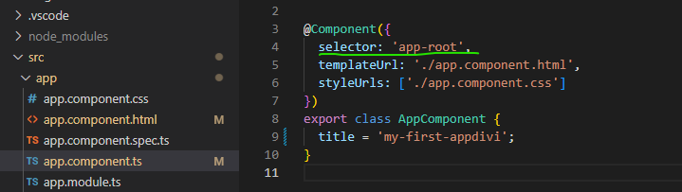

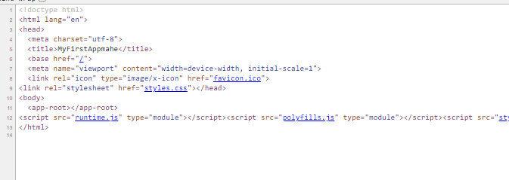

* The page which we view in page source is the: index.html file of src folder . Here the script imports are missing, because they are added dynamically while rendering

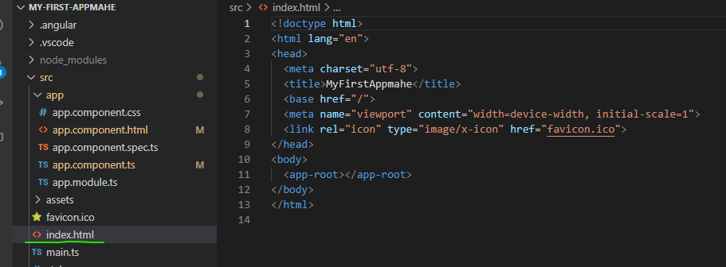

* During rendering, angular replaces the <app-root> with the app-root mentioned in app.component.ts
* App.module.ts -> tells what all pieces belong to our app. To add new modules or packages, we need to add it to imports section of the file . Here we have imported FormsModule and added it to imports section also

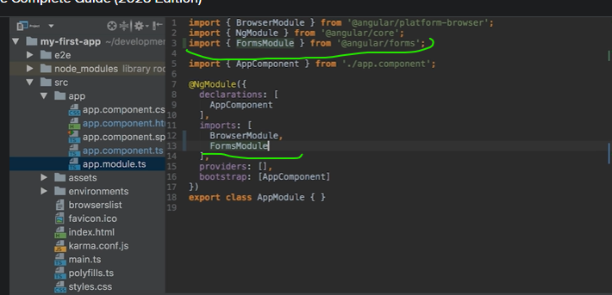

1. **Course Structure:**

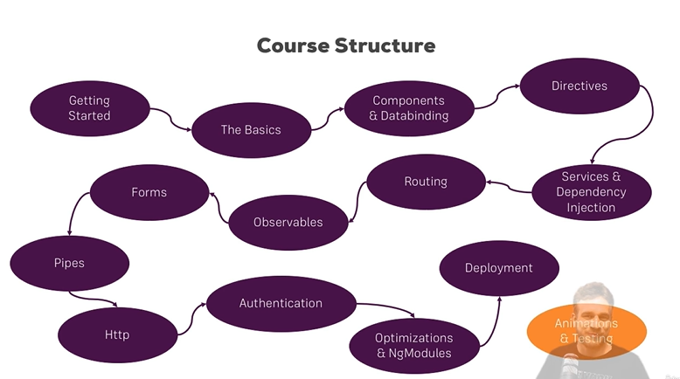

1. **Typescript:**

* TypeScript is superset to Javascript
* Offers more features than vanilla JS.(eg: Types, Classes, Interfaces)
* TypeScript does not run in the browser. So it is compiled to Java script This compilation(conversion from typescript to javascript) is done by CLI
* This compilation is fast

Angular is not used with javascript instead it is used together with TypeScript

1. **Adding Bootstrap CSS framework: to angular project**

* To have nice out of the box css styles
* To add this, we need to install Bootstrap and this installation is local to only the current project
* So it will download boot strap and store it in node_modules folder

*E:\Expeditors_sample_projects\Angular_Projects\my-first-appmahe>npm install --save bootstrap@3*

*added 1 package, removed 1 package, and audited 885 packages in 12s*

*86 packages are looking for funding*

*run `npm fund` for details*

*found 0 vulnerabilities*

* To use bootstrap, we need to make angular aware of this styling package. This is done in one of the config files: angular.json file. This file configures the CLI project
* In architect section, there is already one entry: src/styles.css

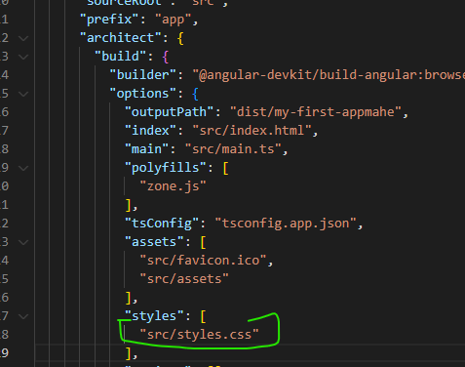

* Now adding the below entry in styles will override the previous entry of styles.css
* "styles": [
* "node_modules/bootstrap/dist/css/bootstrap.min.css",
* "src/styles.css"
* ],
* Once we save this, we need to run ng serve to load these changes